Brochure

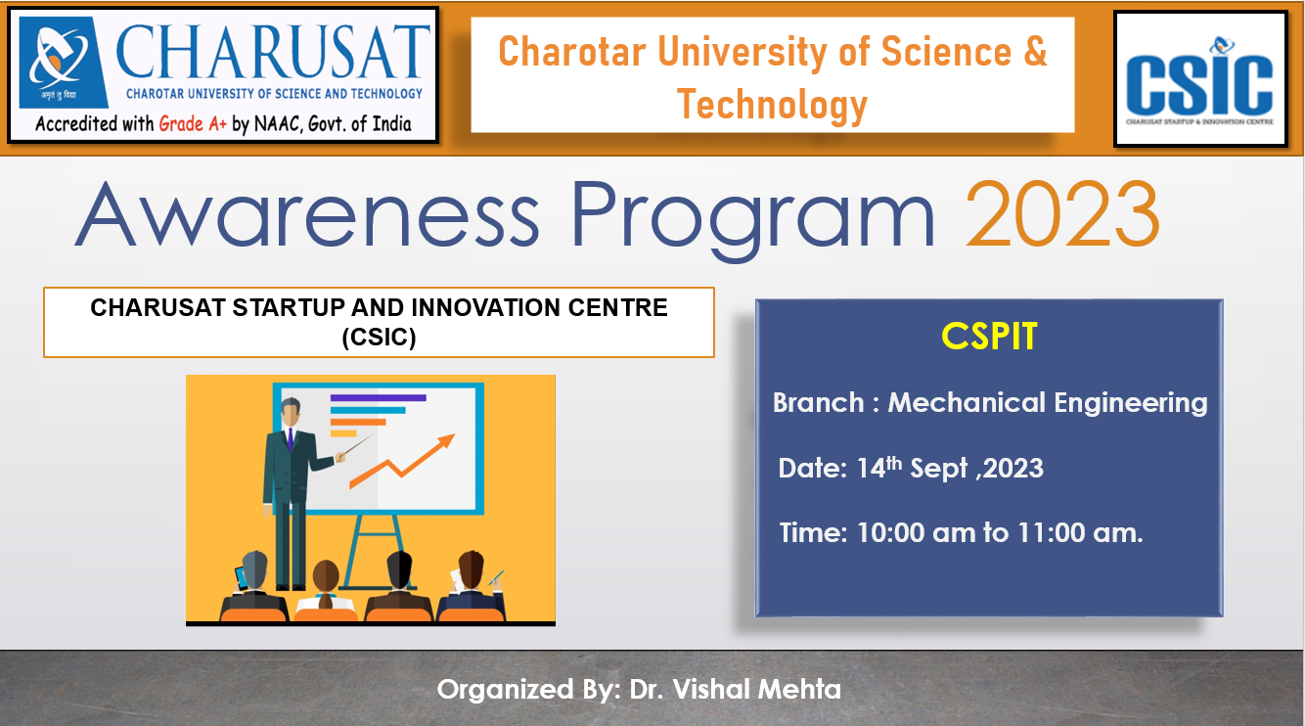

Summary of the

Workshop/Seminar/ Awareness program Organized

Event Type: | Seminar
Title: | CSIC Awareness Program 2023
Topic: | Awareness of the CSIC cell and its activities
Resource Person(s): (with designation, affiliation, email, phone number) | Dr. Vishal Mehta,  Assistant Professor,  Department of Mechanical Engineering,  Chandubhai S Patel Institute of Technology,  Charotar University of Science and Technology, Changa, Gujarat.  Mo. 9328134443, Email: vishalmehta.me@charusat.ac.in
Duration: | 01 Hour
Funding from any Outside Agency: | Nil
Targeted Audience: | Mechanical Engineering Students
No. of Participants: | 43
Registration link | https://forms.gle/1Bf15AeHGF5GjLUX6
Organizers: (Team Members) | Dr. Vishal Mehta

“CSIC Awareness Program 2023”

14/09/2023

Report

Expert’s Name: - Dr. Vishal Mehta

Brief Details of Workshop/Seminar/ program: - The aim of the seminar is to provide awareness about CHARUSAT Startup and Innovation Centre (CSIC), its functioning and activities handle by the cell for the promotion of startup and innovation at CHARUSAT. To make aware of i-Hub and SSIP activities and funding opportunity at different stages.

Detailed Program Schedule

10.00AM to 10.05AM Inauguration

10.05AM to 10.5AM Awareness of CSIC and its functioning

10.50AM to 11.00AM Q & A and Concluding Remarks

Photographs of the Event

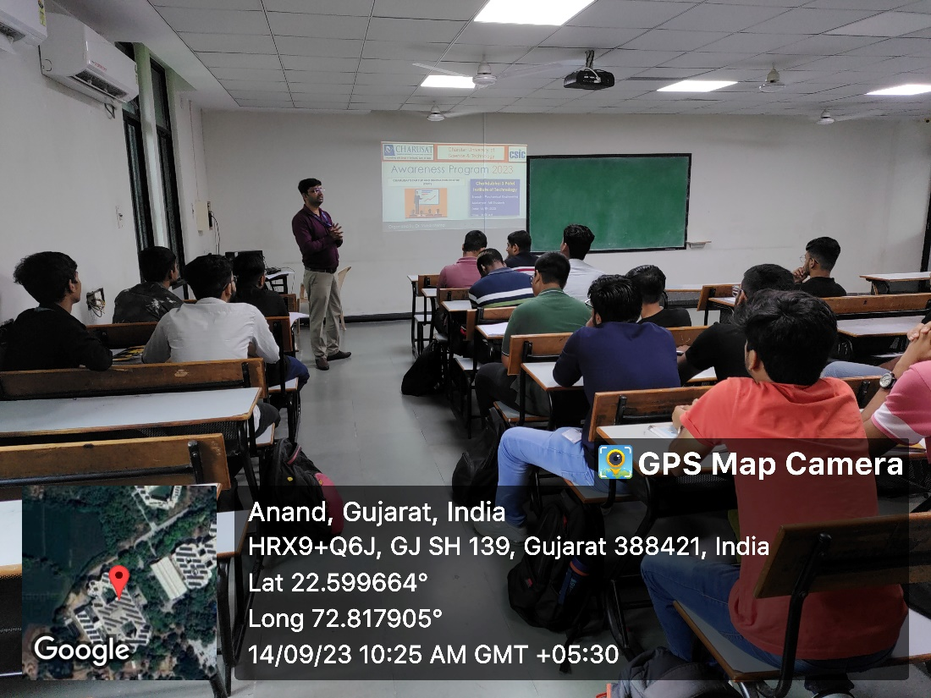

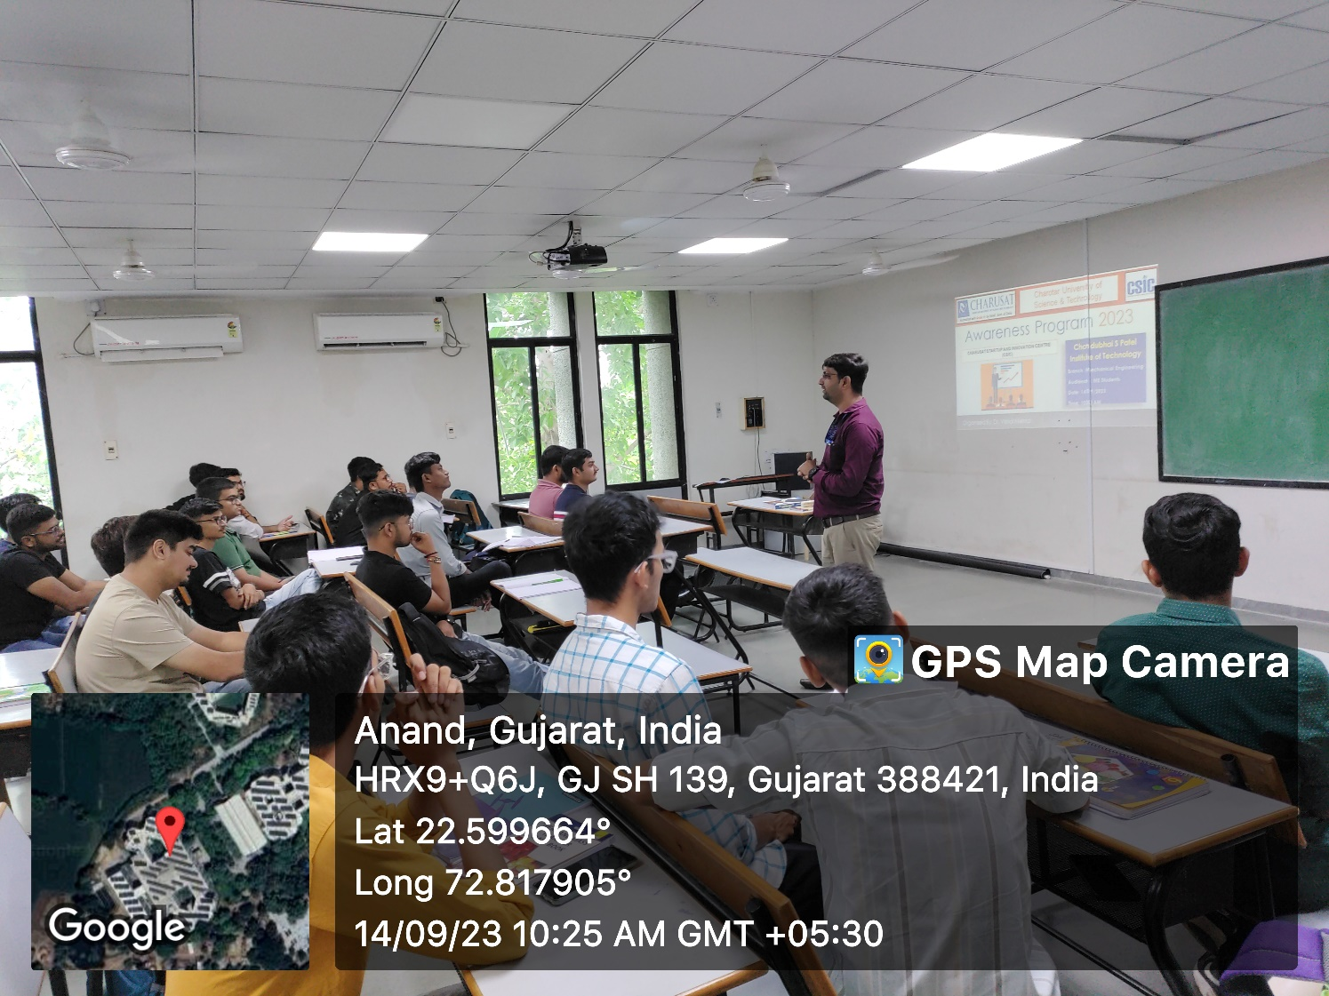

List of Present Attendee

